# Assignment

Build a simple **tvOS** demo application that displays a set of video objects in a so-called “Sushi Lane” (the highlighted view in the iOS screenshot):

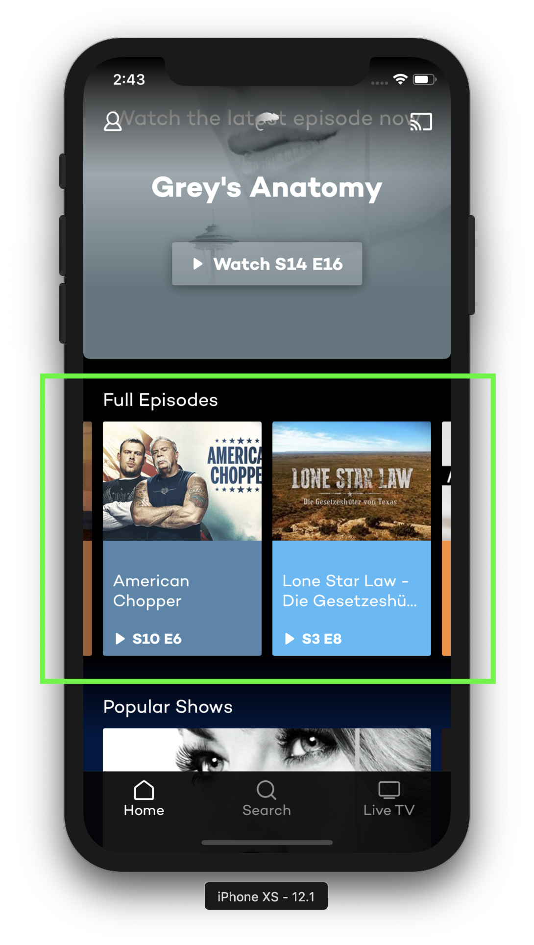

The data should be retrieved from a mock API endpoint providing JSON available at <https://private-f88bc-christianegohring.apiary-mock.com/popular/videos>

To access the images you have to append a profile to the image URL as well as the channel ID, see the following example:

<http://i5-img.7tv.de/is/a26dUrmvuMLNEJCC4sqF__y3mGLQI5dHEo3vrCerSOtBMlWINqEA4Pnjrn6KsuOwrKmlDM4JnSR1pcseDYCfDUHb5d--83v0svHpx1Fh/profile:7tv-868x488/wm:1> where the image profile is constant for all image URLs and the value of “wm” is the respective channel ID of that video object.

Create a model that holds the individual video assets and populate your view with those objects. The view objects should have a “focused” state that shows the current selection.

Displaying an item detail view when selecting a video is out of scope for this assignment. However, you should already have an idea where and how you would implement that functionality.

### What to focus on:

* Architecture

Which architectural pattern did you use for implementation and why? Did you consider a different approach and if so why did you decide against it?

* Readability / Maintainability

What patterns and practices did you use for making the code easily understandable?

* 3rd-party dependencies

Did you use any 3rd-party frameworks for implementing the assignment? If so, why did you choose that particular framework(s) and what would you consider pros and cons of using 3rd-party dependencies in general and the ones you used specifically?